

Where Do Markets Come From? Author(s): Harrison C. White

Source: *The American Journal of Sociology,* Vol. 87, No. 3 (Nov., 1981), pp. 517-547 Published by: The University of Chicago Press

Stable URL: [http://www.jstor.org/stable/2778933](http://www.jstor.org/stable/2778933?origin=JSTOR-pdf)

Accessed: 12/01/2010 15:36

Your use of the JSTOR archive indicates your acceptance of JSTOR's Terms and Conditions of Use, available at <http://www.jstor.org/page/info/about/policies/terms.jsp>. JSTOR's Terms and Conditions of Use provides, in part, that unless you have obtained prior permission, you may not download an entire issue of a journal or multiple copies of articles, and you may use content in the JSTOR archive only for your personal, non-commercial use.

Please contact the publisher regarding any further use of this work. Publisher contact information may be obtained at <http://www.jstor.org/action/showPublisher?publisherCode=ucpress>.

Each copy of any part of a JSTOR transmission must contain the same copyright notice that appears on the screen or printed page of such transmission.

JSTOR is a not-for-profit service that helps scholars, researchers, and students discover, use, and build upon a wide range of content in a trusted digital archive. We use information technology and tools to increase productivity and facilitate new forms of scholarship. For more information about JSTOR, please contact [support@jstor.org.](mailto:support@jstor.org)

*The University of Chicago Press* is collaborating with JSTOR to digitize, preserve and extend access to *The American Journal of Sociology.*

[http://www.jstor.org](http://www.jstor.org/)

**Where Do Markets Come From?1**

Harrison C. White

*Harvard University*

Production markets have two sides: producers are a fully connected clique transacting with buyers as a separate but aggregated clique. Each producer is a distinctive firm with a distinctive product. Each side continually monitors reactions of the other through the medium of a joint social construction, the schedule of terms of trade. Each producer is guided in choice of volume by the tangible outcomes of other producers-not by speculation on hypothetical reactions of buyers to its actions. Each producer acts purely on self-interest based on observed actions of all others, summarized through a feedback process. The summary is the terms-of-trade schedule, which reduces to constant price only in limiting cases. The market emerges as a structure of roles with a differentiated niche for each firm. Explicit formulae-both for firms and for market aggregates-are obtained by comparative-statics methods for one family of assumptions about cost structures and about buyers' evaluations of differentiated prod­ ucts. Not just any set of firms can sustain terms of trade with any set of buyers. There prove to be three main kinds of markets, and three sorts of market failure, within a parameter space that is specified in detail. One sort of market (PARADOX) has a Madison Avenue flavor, another is more conventional (GRIND), and a third (CROWDED) is a new form not included in any existing theory of markets. Current American industrial markets are drawn on for 20 illustrations, of which three are presented in some detail. Inequality in firms' market shares (measured by Gini coefficients) is discussed.

Why do so many of our industrial markets have but a dozen or so member firms, several of which produce substantial shares of the total output (Scherer 1970; Porter 1980)? It is not enough to cite technological constraints. Why, when even the largest of firms wants to offer a product new to it to the public, does it usually do so by acquiring the persona of a firm

1 Financial support under grants SOC76-24394, SER76-17502, and SES80-08658 from the National Science Foundation is gratefully acknowledged, as is technical assistance from Holly Grano. E. Raymond Corey, Michael E. Porter, and others at the Harvard Business School generously made available teaching notes and case studies of industries or sets of firms from industries; they bear no responsibility for the interpretations I propose. In this development of earlier technical papers, Ronald L. Breiger, Robert G. Eccles, Eric Leifer, John F. Padgett, Orlando Patterson, and Arthur Stinchcombe contributed ideas and other aid, as did an anonymous referee. Requests for reprints should be sent to Harrison C. White, Department of Sociology, William James Hall 470, Harvard University, Cam­ bridge, Massachusetts 02138.

© 1981 by The University of Chicago. All rights reserved 0002-9602 /82/8703-0001$01.50

belonging to an existing market? This astonishing fact seems to be over­ looked by existing theory; practitioners and consultants take it for granted (see Salter and Weinhold 1979, pp. 7-16; Steiner 1975, pp. 192, 200).

Why do economists accept a theory of firms in markets which denies in principle the most commonly observed situation of firms? Most industrial firms most of the time decide production volume within a range where their unit costs are constant or decrease as volume increases (see Ijiri and Simon 1977, p. 7).

I developed some tentative answers to such questions in an earlier tech­ nical paper on production markets as induced role structures (White 1981). Here I wish to flesh out the argument and illustrate it by application to a number of current U.S. markets.

What I have proposed is embedding economists' neoclassical theory of the firm within a sociological view of markets. Markets are self-reproducing social structures among specific cliques of firms and other actors who evolve roles from observations of each other's behavior. I argue that the key fact is that producers watch each other within a market. Within weeks after Roger Bannister broke the four-minute mile, others were doing so because they defined realities and rewards by watching what other "producers" did, not by guessing and speculating on what the crowds wanted or the judges said. Markets are not defined by a set of buyers, as some of our habits of speech suggest, nor are the producers obsessed with speculations on an amorphous demand. I insist that what a firm does in a market is to watch the competition in terms of observables.

In my proposal, markets are social structures in which producers repro­ duce their own set of actions; the set confirms as correct each firm's expec­ tations of what it hoped was an optimal volume. This view is a special case of "rational expectations" (Muth 1961; for a recent survey, see Kantor [1979]). In this feedback model there is also a self-selection aspect derived from the "signaling theory" of Akerlof (1976), Spence (1974), and others intrigued by notions of "imperfect information."

A modest generalization of the notion of price is required: generalized to a market schedule of observed outcomes. These observed outcomes are a set of pairs, one pair for each firm: revenue received for volume shipped. Look at the hypothetical outcome sets in the panels of figure 1. Figure 1A outcomes cannot sustain a market, figure 1B outcomes can. Figure lC, in which a curve is interpolated through the points of figure 1B, is one way a firm may visualize those outcomes, revenue *(W)* as a function of volume

*(y).* This schedule must not be confounded with the demand function, a hypothetical construct of economists. This schedule may be perceived in terms of price (revenue/unit), but it is a volume-dependent price. As will be seen below, this generalization of the conventional notion of price is crucial for my approach.

**Revenue**

**Revenue**

w,

**Revenue**

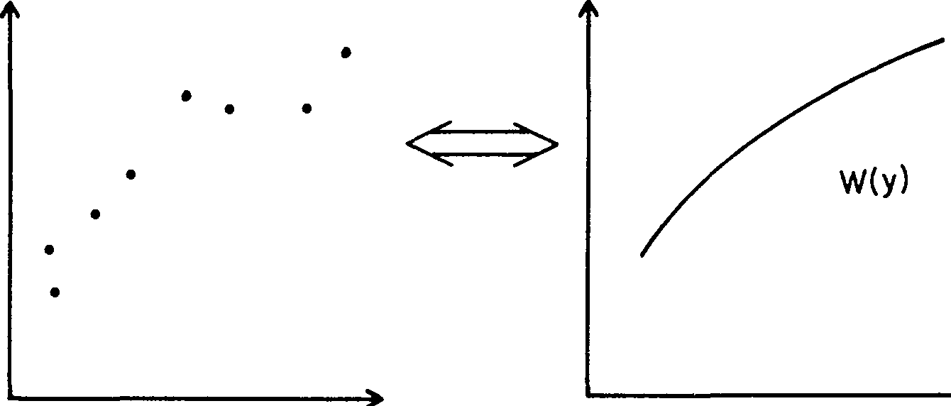

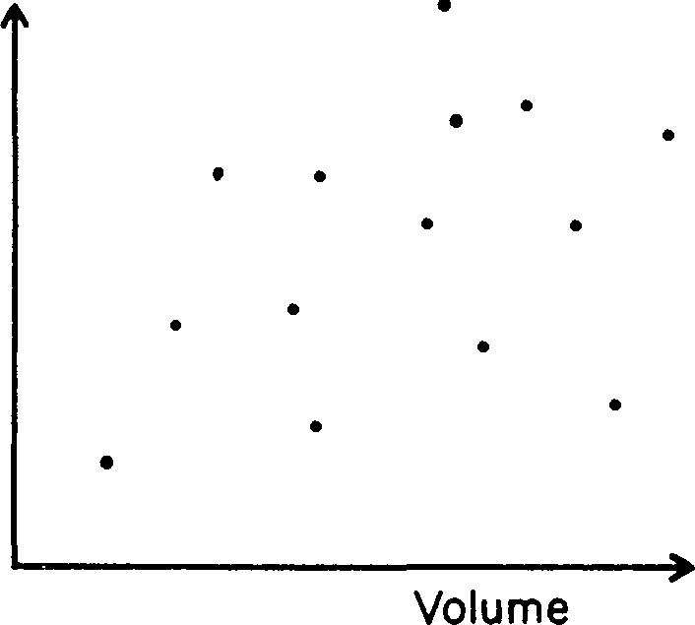Volume y, Volume

**A.** B C

Fm. 1.-Outcomes for each firm in a clique. *A,* Outcomes do *not* sustain a market. ***B,*** Outcomes *do* sustain a market. *C,* Market schedule inferred from ***B;*** decisions using it sustain it.

Because it frames the only hard, tangible evidence available, each firm treats *W(y)* as its own opportunity set. Obtaining even that much informa­ tion requires alert inquiry-over luncheons with others in the trade, from trade associations, from one's own customers, and so on. Each firm knows that its product is distinctive, but it also knows the difficulty and risk of assessing one's own distinctiveness (see Corey 1978; Porter 1976). In par­ ticular, when the total volume one offers in the market changes, its attrac­ tiveness to buyers changes, in ways hard to estimate. No firm can reliably assess relative qualities of other firms, and every firm knows that its position could be affected by choices made by any one or more of its competitors. The market schedule *W(y)* is a shared social construction incorporating all the interaction effects.

Such mutually interlocking confirmations of a unique choice by each producer (fig. *1B)* are not possible for any arbitrary collection of producers and any population of buyers. A variety of attributes may distinguish indi­ vidual producer firms (product quality, location, plant investment). On the one hand, some of these attributes affect cost structures (e.g., figs. 4 and 7 below) and thus the production level which looks optimum to that firm. On the other hand, some of these attributes influence attractiveness to buyers. A self-confirming market schedule, *W(y),* is induced here for a clique of products whose cost structures and taste structures can each be ranked by quality.

A market is an "act" which can be "got together" only by a set of pro­ ducers compatibly arrayed on the qualities which consumers see in them. Quality arrays have recently figured in microeconomics under the rubrics of "hedonic prices" (Terleckyj 1976) and "consumer as producer" (Lancaster 1966, 1979). Nearly 20 years ago Alonso (1964) proposed an array for loca­ tions in a city, where distance from the center provides a natural metric

for equality but also geometric constraints on areas, his analogue of volumes; more recently Rosen (1974) has generalized this schematization to imperfect competition.

Building a market is a conflict-ridden and erratic process with quite a range of outcomes possible in the form of market schedules. The various firms' products will presumably be akin within a market, but we do not as observers impose any a priori cultural or linguistic criterion of similarity. Markets are defined by self-reproducing cliques of firms, and not the other way around.

The body of this paper is divided into a section on the general model and a section on applications and results.

THE GENERAL MODEL

Firms in the market differ from one another, not only in cost structure but also in appreciation of their products by the buyers. These dispersions occupy center stage in my analysis. In this respect I follow the long-standing tradition of economic studies of "imperfect competition" initiated by Chamberlain (see Dixit and Stiglitz 1977; Spence 1976). But that tradition has firms using conjectures on buyer taste to decide their market offers. In contrast, my view, presented above, is that firms decide on the basis of observed positions of all other producers.

In my view, firms seek niches in a market in much the same way as organisms seek niches in an ecology. Because each firm is distinctive, they are engaged not in pure competition but in finding and sustaining roles with respect to one another given an environment of discerning buyers. But there is no auctioneer to shape the market; instead, its structure depends on the interlocking of local orders. This leads to the postulate that firms with neighboring cost schedules (amount of variable cost to produce various volumes) must also have, in the eyes of buyers, neighboring schedules of valuation with respect to volume. If the postulate is not satisfied, the nascent market situation, a set of producers with an attendant population of buyers attracted by them, cannot sustain itself: *W(y)* will not be repro­ duced through the self-interested actions of firms, checked by buyers.

In an observed market, the producing firms are dispersed in quality of product perceived by buyers as well as in volume produced. By the pos­ tulate of the preceding paragraph, neighboring qualities must lead to neighboring volumes of production. In the model each firm is assigned a value on an index of quality, denoted by *n;* the value assigned is charac­ teristic: an attribute which cannot be changed quickly as can the volume of production. The volume of production is denoted by *y.*

The key feature of my approach is this: *Firms can observe only volumes and payments, not qualities or their valuations, and they act on the basis of*

*these observations, thereby reproducing the observations.* My model, however, can predict all these volume choices by different firms because it assumes knowledge of quality, *n,* for each firm, as well as valuations. (Higher values on this index are defined as higher quality-always as judged by buyers' evaluations.)

First I develop the cost and valuation schedules, and then I derive the range of market schedules that may result from a given set of facts. A topology of markets-a two-dimensional array with each point a particular shape of payment schedule-follows as a by-product. The varieties and implications of market failures are then discussed before the second part of this paper: applications and predictions for industrial markets.

The central theme proves to be a trade-off between dispersions, an affair of variances rather than the matter of means one might expect from the cliche of supply equaling demand.

The Facts of Cost and Value across Volume and Quality

The primitives of my description are two schedules (of cost and of valuation), each given in terms of two dimensions (volume *y* and quality *n).* If the facts about a set of firms and buyers cannot be approximated in terms of nested schedules,2 those producers and customers will not be able to sustain a market which reproduces itself as in figure 1. In order to achieve a compre­ hensive yet clear inventory, I shall specialize to particular families of power functions to describe possible schedules.

The schedule of the firm characterized by *n* for variable costs of produc­ tion is

*C(y; n)* = *qy"/na,* with *q* and *c* positive.

The firm's contribution to buyer valuation is defined as

*S(y; n)* = *ry°'nb,* with *r, a,* and *b* positive.

**(1)**

(2)

Intuitively it is clear that a balance must be struck by the market between the trade-off taking place between *contribution* and *cost,* with respect to more volume or less volume, on the one hand, and the trade-off between *desirability* and *expense* with respect to quality, on the other. Equations

2 *Nested* means simply that the function describing a schedule defined by one value of the parameter (e.g., n) never crosses the function for another value of the parameter. (The concept, though slippery, is familiar and important in other areas, such as Lorenz distribu­ tions; see Schwartz and Winship [1980].) This assumption, as well as the more basic assumption that each empirical schedule can be represented by a perfectly sharp function (see n. 10 below), clearly is more stringent than necessary to obtain the main findings. But to simplify explanation of the theory in these first papers, I make not only these assumptions but also the further assumption that particular Cobb-Douglas (power-law) forms are appropriate for the schedule. Elsewhere I have explored alternative functional forms.

**(1)** and (2) yield the simplest family of schedules that allow these four independent variations of schedule as measured in total dollars and with respect either to physical volume *y* of production or to its quality *n.*

Figure 2 schematizes the phenomenology underlying these schedules. It explicates equation **(1)** as the variable cost of producing the volume *y* chosen by a firm being the product of the volume-sensitive *cost* and the quality-sensitive *expense.* Cost must increase with volume so that the exponent *c* is positive; this exponent gives the proportionate logarithmic rate of increase with volume. *Quality,* unlike volume, is in the eye of the beholder, here the buyers, and therefore is an exogenous "social fact" confronting the producers; so the exponent *d* can be either positive or nega­ tive. When positive, *d* describes what I denote below as a PARADOX market in which a producer whose product is liked better finds it less costly to make! There is in figure 2 a parallel rationale for equation (2). By defini­ tion, the exponent *b* for desirability is positive; one could even insist that it be set equal to unity, but I prefer not to constrain the scaling of quality values *n* for different firms' products in that way (see discussion of tables **1** and 2 below).

On the buyer side there is an asymmetry which is not captured in figure 2. Firms are the active decision makers; each has an independent cost schedule

1) Phenomenology of Market Context

Dispersions

s

|  |  |  |
| --- | --- | --- |
| on Volume (y) of Firm's Production | | on Quality Index (n) |
| Valuation | Contribution of the product  increases with volume, as perceived by the buyers | Desirability of the product increases with quaIity as Judged by the buyers |
| Costs | Cost of production increases as volume increases | Expense of building in the quahty changes (+ ar - )  with increased quality |
| Increases With Volume | | Changes With Quality |

C

h e

d u I

e s

across Firms

ii) Parameters -- Proportionate (log) Rates

a b

C **d**

1 i 1) The Basic Tradeoffs

-- Over variation, in product volume

-- Over variation in producers' quality

FIG. 2

Contribution = *ale*

Cost

Desirability = b/d Expense

known to itself (at least). Buyers, on the other hand, are lumped together as an aggregate, in a passive role. The aggregate buyer may say "no" to the market entry (volume and price pair) offered by a firm, but it has only this binary choice. This binary decision depends on how the buyers in aggregate evaluate more of one firm's product against less of another's. To simplify the model further, I assume that buyers do not see particular pairs of products in interaction, but only the set of products. In formal terms, the buyers in aggregate value their total array of purchases as

*V(#)* = [2: *S(y; n)]'Y.* (3)

The symbol *V* for this valuation is in boldface type to signal that it is an aggregate quantity over the whole market: I adhere to this convention throughout. The symbol # gives the number of firms in the market and hence the number of terms in the summation. Observe that the contribu­ tion of one firm's product volume to the total valuation can replace the con­

tribution of any other firm. In the special case in which the exponent *a* is unity, further volume increments from a given firm are neither more highly valued (as they would be with *a* > 1) nor less highly valued than a begin­

ning volume. More decisive is the overall exponent 'Y (gamma) which is usually less than unity; this corresponds to a saturation of taste, for the sum of purchases from all firms in the market, by the given aggregation of buyers as the aggregate volume purchased increases.3

The scale factors *q* for cost schedules (eq. [1]) and *r'Y* for valuation sched­

ules (eqq. [2] and [3]) are worth keeping distinct. In the section on applica­ tions, changes in these will be interpreted as exogenous shifts in cost and demand imposed on the market. I do not define a distribution of firms over the quality index *n,* only their number. In this view of markets there are relatively few member firms as producers, as few as a half dozen, and there is no reason to suppose any particular spacing on the quality index among those few: These are best treated as a set of constants to be fitted to the observed producers (as is done in several empirical examples later).

Certain special cases bear considerable weight in the past development of theories of markets, a point I develop at length elsewhere (White 1980). Setting the exponent *b* to zero reduces the market to pure competition: products of different firms are indistinguishable. Perfect competition models assume in addition that there is no taste for sheer diversity on the part of

3 In this simplified representation (eq. (31) of aggregate buyer evaluations across products, I follow recent innovations of microeconomic theorists (e.g., Spence 1976; Rosen 1974; and see Lancaster 1966). Note that demands for different products interact in this repre­ sentation *only* because 'Y is not unity for that market. Each *S* function reports propensities toward evaluation based on that product's attributes, but only in the context of the other products can it be incorporated into an actual valuation **(V)** with monetary dimension. Observe that the contribution, at the margin, to ***V*** from any particular firm is its *S* times

'Y;vc1- >, .

buyers-in my terms the exponent *a* is set at unity. It is in this highly specialized context that the notion of supply equaling demand became prominent. Below we see that, although equilibration of aggregate amounts sought and sold is certainly necessary, it is a secondary outcome of the main issue, which is the terms on which aggregation can be carried out meaning­ fully with diverse products. Supply and demand denote one aspect of the feedback processes which shape markets, but not the behaviorally relevant one or, therefore, the theoretically relevant one.

Motivations and Equilibrium Schedules

Each firm, characterized by its quality *n,* chooses its volume of production, *y(n),* to maximize its cash flow, which is the excess of market receipts over out-of-pocket costs. (In this I follow neoclassic orthodoxy and disregard the behaviorist argument for cognitive and motivational limits to optimiza­ tion.) In equilibrium the frame of choices used must be exactly the observed market schedule defined in figure **1:** the *W(y)* of market receipts for volume shipped.4 It is the same frame for each firm, even though we as observers know just how firms differ on quality and thus in cost and valuation schedules. How can this be? It can be only if each firm, because of its own cost structure, is led by the same common schedule *W(y)* to choose a distinctive niche *y(n)* of its own, which niche furthermore satisfies the aggregate buyer that it constitutes as good a buy as any other producer is offering. This is

my definition of a market, which I shall now formalize and extend.

The buyers in aggregate are able to impose only a necessary condition (eq. [4]) for their net benefit to be maximized. By definition, their net benefit is their total evaluation of purchases, the *V* of equation (3), less the sum of the payments made to all# firms, the sum of *W[y(n)]* over each firm. The

4 A scenario can help as illustration. Suppose some particular firm, say Medusa (actual name of a firm in the market-for-cement illustration later) thinks it can command more than this schedule. Suppose Medusa picks a particular volume, y0, at which it hopes to get a revenue *A,* which is larger than the schedule amount W(y0) and optimizes Medusa's net return, given its hypothesized schedule lying above the *W(y)* drawn through observed market entries. Suppose yo is larger than *y(m),* where *y(m)* is the (unique) volume which optimizes Medusa's net return given the existing *W(y)* and yet keeps Medusa's offerings in line as no more or less attractive to buyers than the other firms' offerings. If volume y0 is actually sold, less than the volumes indicated from previous market results for the other firms will actually be sold by them; so their optimization computations are falsified, and they must scramble to readjust by lowering prices and/or volumes in search of a self­ confirming schedule. But then even the *W(yo)* level scorned by Medusa may not be sus­ tained in the lowered schedule eventuating from the scramble, so that Medusa's hope for revenue *A* need not be validated, and in any case it will perceive a changed situation and a recomputation of optimal volume. More likely, not all the intended y0 will be sold, since the price was above the price sustainable from the market schedule, at *y(m),* and indeed at too high a price none at all might be sold, stimulating each of the others to expand a bit to fill a perceived gap. In either event, the *W(y)* market schedule will be unstable. I therefore suppress such transient readjustments and focus only on what mutual configura­ tions of volumes and prices among firms can sustain themselves in equilibrium.

necessary condition is that each firm's *y(n)* yield the same ratio of contribu­ tion to *V* over payment *W[y(n)].* Incorporate this ratio into *8* (theta) (see n. 3):

*S[y(n); n]* = *8W[y(n)].* (4)

The firm indexed by *n* need not and does not know this contribution func­ tion, *S,* of course, or even its own index value *n;* in equations (2)-(4) we are stipulating possible factual situations around the market in order to see what happens given the way firms behave. There is no market mechanism whereby buyers can coordinate insistence on that particular value of *8* which would maximize their aggregate net benefit.

It is straightforward computation (White 1981, eqq. [8]-[15]) to find any schedule *W(y)* which can sustain itself under the pressures and through the choices of these actors on the two sides of the market. The result is

*W(y)* = *(Ay(bc+ad)/b* + *k)b/(b+d)* , (5)

subject to two auxiliary sufficiency conditions. (The constant coefficient *A* is specified below in eq. [11].) Each producer must by its choice of volume satisfy equation (4), and this determines *y(n)* in terms of the *W(y)* of equation (5) (as specified below in the dissection of aggregate supply and demand). But every producer's own goal is to choose that volume which maximizes cash flow; this fact yields the two auxiliary conditions.

First, the shape of the schedule in equation (5) guarantees only that each producer firm can find a distinctive niche that yields it an extremum of cash flow; so, to be realistic, the shape must satisfy a second-order condition for maximization, which reduces (White 1981, eqq. [16]-[18]) to

*d (C*- *a) Ay(bc+ad)/b*> *da k*

*b* + *d b* ' (6)

for a given volume *y.* Second, a producer firm will not remain in the market unless its optimal niche (at which cash flow, *W* - *C,* is maximized) in fact yields a positive cash flow to put toward overhead costs and profits. This second inequality can be reduced to a form parallel to the first one in (6):

*Ay(bc+ad)/b* > *-k.* (7)

*The presence of an arbitrary constant k,* not fixed in terms of other param­ eters and rates in the system, is the first of two key features of the formula

(5) for the market equilibrium schedule. We see that the two auxiliary conditions (6) and (7) can be taken as possibly limiting the volumes (the *y* values) and thus the underlying fixed attributes (the n's) of firms seeking niches in this market. Or, in some parameter settings, there may be no volumes and thus no quality attributes, *n* values, and thus no firms that can yield a market equilibrium with some values of *k.* Qualitatively, *k* can be seen to set the location of the curve described by *W(y),* positive *k* leading

to higher payoff for given volume to the delighted eyes of producers. Historical idiosyncrasy is one way to think of the formation of k-as the almost accidental by-product of a number of producers jockeying for volume and payment sustainable in the presence of the other producers' offerings. It is also clear that a firm can, by cutting its asking price for the same volume, achieve--if it has any motive to-a lowering of the schedule, in effect a change of value of *k* in the viable equilibrium schedule. (A firm which tries to raise its charge for a given volume above the established terms-of-trade schedule holding at that time may simply find itself with no sales at all: sharp discipline indeed [see n. 4 above].)

The second outstanding aspect of the form for equilibrium market schedule *W(y)* in equation (5) is the *mixed nature of its exponent* as a (shifted) power function of volume *y.* The power function form follows, of course, from our use of families of power functions to describe the facts both of cost schedules and of valuation contributions (eqq. [1]-[3]). The interesting question is how this overall exponent, of *y* neglecting *k,* namely,

exponent =***b*** +*b d c* +***b*** +*d d a* , (8)

represents a balance between trade-offs on the underlying dimensions of volume and of quality in the costs and valuations. The two trade-offs of interest are (as mentioned above) the ratio *a/c* for volume dependencies ("contribution"/"cost") and the ratio *b/d* for quality variations ("desir­ ability"/"expense").

This view of industrial markets insists on and points up the social com­ ponent which is heavily interlaced with technical and engineering facts and with buyer needs. Instead of a unique equilibration of supply and demand, or devious schemings by speculators in psychology and taste, we see a his­ torically shaped structure of roles among a stable set of producer firms or, if you prefer, an adaptable ecology of niches among a crowd of competing organisms. In either metaphor the actors are making effective decisions on the basis of tangible observations of the actions of their confreres. The market is a public feedback mechanism for trading off divergences among firms and between them and buyers.

A Topology of Markets, and Their Vulnerabilities

We can project on a two-dimensional screen, figure 3, the mutual distanc­ ing of sorts of markets from one another, since the preceding section shows that the two ratios *a/c* and *b/d* suffice to identify quantitative axes of differentiation. But to identify market results and failures across regions on this screen accurately we must be explicit about how the set of# firms in a market coalesce into stable market aggregations. There is an additional

feedback loop implicit in eqs. (4) and (5), one vulnerable to disruption in the terms of inequalities (6) and (7).

Figure 3 has no left half, since variations with volume (a and *c)* must both be positive. Figure 3 has both a top half, with *d* > 0, and a bottom half, with *d* negative. Positive *d* occurs when correlation of production cost

with quality across firms is negative, and conversely for *d* negative. In the bottom half, new notation must be introduced to avoid confusion:

for *d* < 0: 8 = - *d* . (9)

In markets identified by points in the bottom half of figure 3, the producer whose goods are liked better by buyers is laying out more in costs of produc­ tion for a given volume of goods. As one might expect intuitively, there proves to be a richer array of market types-and ones sustainable across a wider range of contexts-than is true of markets from the upper half of figure 3.

"Decreasing returns to scale" characterize markets located to the left of the line in figure 3 for *a/c* = 1 (or just *c* < 1 in many texts). "Increasing returns to scale" are supposed, in economic theory (Ijiri and Simon 1977,

Decreasing returns to scale

Increasing returns to scale



Costs down as quality up

d 1s positive

PARADOX

Pure Competition

Failed

t 0 , ,. .._, -'--

**4-**

Costs up as quality up

/

d is negative

GRIND

-1 /

/freelo/2

i11/i Failure due to */2*

**CROW ;;;t h**

I

*ale=* 1/y

FIG. 3.-Trade-offs in cost versus valuation, across growth in quality (ordinate) and in volume (abscissa).

p. 7), to be inconsistent with sustainable markets. But in my view of market structure, such markets are viable as long as the exponent *d* is negative, so that cost is higher for higher-quality firms.

Three sorts of market failures can be distinguished in this model.

The only factual contexts absolutely inhospitable to markets, as self­ supporting social structures, are those identified with the upper right in figure 3: increasing returns to scale *and* quality correlate *negatively (d* > 0

in my convention, eq. [1]) with cost of production. In such contexts, there is nowhere to "shift" the trial market schedule, that is, no value of the constant kin equation (5) for *W(y)* which will permit satisfying both con­ straints (6) and (7). Any positive *k* yields a schedule which permits dis­ tinctive niches only for producers who are masochists attempting to minimize their cash flows. Any negative value of *k* so depresses the terms of trade to producers that no firms are able to achieve positive cash flows.6

All other factual contexts, all other parts of figure 3, should at first sight permit at least some equilibrium schedules. There is usually *some* value of *k* which satisfies both constraints (6) and (7).6

However, these otherwise viable ranges of market schedules may under some circumstances encounter one of two forms of instability. First, "free­ loading" can unravel a market schedule which at first sight is viable, given firms with a whole range of qualities. In formal terms, "freeloading" results from the wrong kind of overlap between volume regions allowed by one and by the other of the inequality constraints (6) and (7). Return to the point in the **PARADOX** region; for any positive *k* value, a range of *y* exists which does not yield optimal niches for individual firms yet does yield positive cash flows. Then it is easy to show that all firms with quality indices *n* in the appropriate range would choose some "edge" value of volume as their ("corner") optimum among possible choices; yet they would not yield value for money to buyers: the ratio *S/W* would be less than *O* (see eq. [4]). Thus that part of the schedule over volume, *W(y),* will not be sustained; but the same problem will reemerge (with a somewhat different set of firms, from a shifted range on the quality index *n)* for the abbreviated schedule, and in the end it will unravel completely. For any value of *k,* positive or negative, the lower-left trapezoidal region in figure 3, a region of contexts which yield proper markets by existing market theory (Spence 1976), is

6 Innumerable specific scenarios could show how a particular set of firms and buyers describable by a point in the upper right would blow up any trial schedule. Parsimony requires stating, as in the text, just the allowed structures and the static criteria which discriminate them; these are given in more detail in White (1976, 1981). But examples of scenarios may help the reader's intuition: seen. 4 above and the case studies below.

6 In White (1981, table A), I report, for each detailed subregion of the trade-offs plane, the exact range of *k* values which always yield stable payment schedules. This range can be larger if not all possible levels of quality *n* are present in the market; so there is interaction between range of *k* and range of *n* (worked out in detail in White [1979], pp. 54-57).

vulnerable to freeloading. That is, if firms of all possible quality levels are in the wings seeking possible entrance to that market, for no one of those contexts can any schedule at all (any *k* value) yield a sustainable market.7 Second, there are constraints on viability because of possible explosive feedback effects in the process by which aggregate market size builds.

Feedback in aggregation can be schematized as

*.w[y( n)]*

*W(y)* - *y(n) /8* - *W(y)*

*V(#, y(n)'s)*

(10)

The ratio *8* ties a market schedule faced by individual firms to the aggregate size of market. This is seen from the specification of the constant *A* m formula (5) for *W(y):*

*A* = *(b*- 8)*C q( )6/b*

*be* - *a8 r*

(11)

This is a classic feedback indeterminacy in which the production volumes depend on the height of the payment schedule, which to yield equilibrium must depend just so on the actual production volumes chosen by all the

# firms. The arbitrary shift constant *k,* as well as the ratio *8* as shown above,

enter the determination of equilibrium volumes *y(n)* and payments *W[y(n)],* so that in general a numerical solution is required. The special case of *k* = **0** yields guidance in the form of explicit formulae for aggregate sizes, which yield market coefficients *8* and *A.* These formulae (in White **1981)** show that the aggregate cash volume of the market, namely, *W,* is unbounded when

*C* < *a'Y* (12)

so *a/c* = lh is marked on figure 3 by a dotted line (since it applies only for *k* = O) and the region to the right is marked EXPLOSIVE. 8 (In the upper half of the figure, for *d* > 0, unbounded growth of aggregate volume begins at *a/c* = 1, the traditional demarcation of "increasing returns to

scale" remarked on above.)

In the next part of the paper, numerical examples reporting aggregate

7 To put it positively, and in more conventional terms, a market can be sustained at a point in this region only if there are high barriers to entry (assuming the initial set of firms set a self-sustainable schedule in motion). Such "metastable" markets, in this lower­ left region of the factual trade-offs plotted in fig. 3, should be sought; testing presumes not only measures of *a, b, c,* and *d* but also following a putative example over time for evidence of barriers. Barriers can be of many kinds: legal, capital (sunk cost of facilities, establishing distribution, etc.) (Scherer 1970; Porter 1980).

8 In words: demand is such relative to costs that each producer can keep raising his choice of volume (and perhaps also new firms enter) and yet find that the market sustains the price he envisioned. My comparative statics model cannot, of course, capture this un­ bounded escalation as a process, or the bounding effects which must set in. New products­ whether color TV in 1965 or hula hoops in the late 1950s---are plausible cases.

sizes and market distributions will illustrate how viable markets in one region of figure 3 differ from those of another. One final general distinction should be drawn here. The lower region marked CROWDED, just short of the EXPLOSIVE region, has "increasing returns to scale." Such markets are viable because buyers have no means to realize or organize to exploit the realization that they are better served the *fewer* the firms there are.9 Under these conditions, the aggregate size of the market, *W,* actually decreases when a new firm enters and finds a niche on the market schedule.

APPLICATIONS

I report three classes of applications. First, I illustrate in detail each of the three viable market regions with a model of a current U.S. industrial mar­ ket.10 Second, I locate a wide variety of empirical markets within my topology. Finally, I illustrate the concentration implications of my model, via prediction of Gini coefficients.

Three specific markets-those for cement, light aircraft, and disposable diapers-provide my illustrations of the three viable market regions.

1. Cement. Empirical sources for this and the other two illustrations are given in table 3 below. Eight firms dominate the current U.S. market for cement considered as a national one:# = 8. Their names are attached in figure 4 to the cost schedules which I assign to each. (The corresponding

valuation schedules, the S's of my model, are not shown.) Firms with higher cost schedules also have higher value schedules, so that *d* is negative. My best estimate is that the cement market is described by *a* = .8, *b* = 1,

*c* = 1, *d* = -2 (c5 = 2), and 'Y = .7 (with rand *q* each set to unity). This puts the cement market in the middle of the triangle in figure 3 just below

the pure-competition line segment. At the top of figure 4 is one viable equilibrium market schedule (heavy line). It has *k* = 0, which in this GRIND region is the lowest value of *k* not vulnerable to freeloading.11

9 When in fact buyers are highly or totally concentrated-e.g., in purchase of automobile windshield wipers-and the ranges of trade-offs for this region apply, one would expect it to be impossible to form a market (for further discussion see White [1976, 1978]).

1°Cost and value functions, and index values for *n,* are chosen to give the best appearing

fit for available data, within the constraints of the functional forms assumed earlier.

These are illustrations rather than fully developed implementations from and tests of the *W(y)* model. Full implementation would require tests of goodness of fit of the power functions forms to cost and other schedules. Full implementation is likely also to require introducing stochastic "fuzz" terms into all the schedules. Grossman (1975) has sketched a Bayesian implementation of another kind of rational expectations theory of markets, in which he emphasizes stochastic terms (but leaves producers undifferentiated); in sec. 4 Grossman specifies one simplified estimation framework for Cobb-Douglas forms like eqq.

(1) and (2) above.

11 Given the range of quality values *n* which I report for them, none of this set of eight firms would be in the temptation region for freeloading. But who knows what obscure local producers might be watching from the wings?

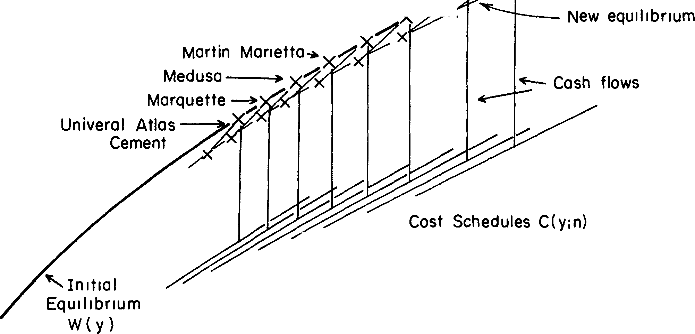$ Lone Star Industry -- Low quality, low Ideal Bas,c Industry--+x - price firm **enters:**

.12

06

G1fford-H1II - General Portland

Cement Market (GRIND REGION) a=.B, b=l, c=l, d=-2, r=l; q=l, *r=* 7 k= 0

80=978

W(y)

05 09

Fm. 4.-Market schedule before and after entry of an additional firm into the cement market.

Arbitrarily, I have used that value of *0* which merely breaks even for the buyer side.12

Just below the heavy line in figure 4 is a second market schedule, the one which could result if a brand new firm entered at low quality and high volume, as shown (this is a hypothetical, unnamed firm). The changes suit common sense: each other firm loses some volume, as well as by definition some market share, and loses it in sales as well as in physical volume-yet the aggregate size of the market, including the hypothetical ninth firm, is increased. As a test of understanding, the reader should establish what hap­ pens to the prices charged by the various existing firms (see last figure in White [1981]).

The companion figure 5, for the same industry and the same initial equilibrium schedule, shows what the new viable market schedule could become if general cost level *q* for cement producers went up by 20%. In addition, a similar comparative-statics shift of schedule shows what would happen if consumer demand *r* rose by 10%. (In each case the new schedule remains at the break-even *0* value for the new context and *k* remains zero.)13

12 This is the 00 or *t* = 1 case used for calibration in White (1981), eqq. (22)-(27). A ratio­ nale is that cement buyers are unlikely to be greatly interested in doing optimally well on their purchases, just on getting enough of the right stuff.

13 In these illustrations, firms were selected and quality index values (the n's) were as­ signed so that an orderly terms of trade schedule would result (production volumes or market shares of revenue were the only given data, in addition to discussions of the industries from which *a* and *c* were derived). In the absence of complete data, these unfalsifiable selective processes are unavoidable. Once the firms and quality index values have been fixed on the basis of available data, however, predicted effects of "exogenous" changes (embodied in rand *q)* can provide an opportunity for falsification of the theory.

$

Cement Market - 8 firms

(GRIND Region a=0, b=c =1; d=-2; =0.7)

k=0 t= l

*t* New Schedule after

consumer demand increase of 10% (in

*or c::-* New S hedule tter

-- 20 % increase in

production cost level (q)

.20

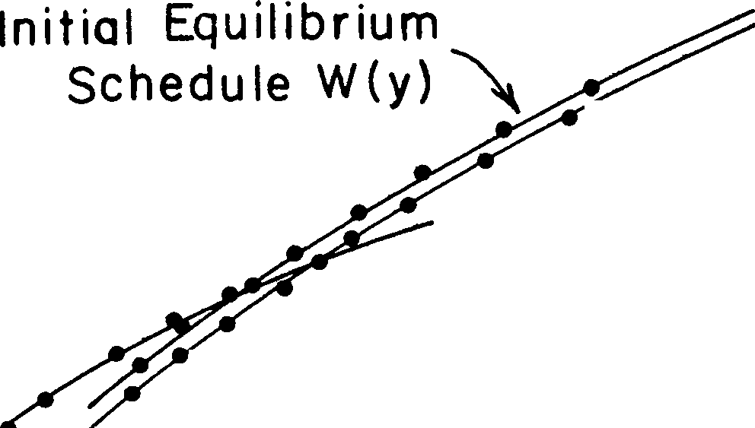r)

.10

.05 .10

**Volume y**

Fm. 5.-Impact on market schedule of exogenous shifts in cost level (q) and demand level **(r).**

In this market from the GRIND region (in sharp contrast to some shown below) the shift in consumer demand makes very little difference, either in aggregate or in divergences among firms. Each of the eight firms is shown as a dot on each market schedule, so that one sees not only the shift in schedule perceived but also the net shift, after feedback, in volume chosen by a given firm from the shifted schedule of perceived offers. Note that the *increase* in demand, via the feedback, *decreases* each firm's volume and price.

1. Light aircraft. The second detailed illustration is more counterintuitive as a market. I choose a location in figure 3 in the CROWDED region; the actual industry I shall use as an approximation is the manufacturing indus­ try for light aircraft used for recreational flying. There are but three firms currently in this market (Cessna, Piper, and Beech), the minimal number for the theory to make sense but also a very convenient number for ex­ hibiting findings.

Table **1** reports four different changes of equilibrium market schedule, and for each of two values of the shift constant *k* (in each case at the break-even *8* for that context). Because there are but three firms, I can report all these schedules in one table of the numerical values. Cash flow *(W* less cost) and price are included as well as the schedules *W(y).*

There is a change in interpretation which I introduce just for this example.

In all equilibrium schedules in table 1, the physical volumes of production for the three firms are kept fixed, and fixed at the levels actually observed in the light-aircraft market in 1969. So a changed schedule is found by computing the changed *quality* index *n* for each firm needed to yield each the same volume as before. But it is just the quality index *n* that is to be thought of as an attribute of the producer which is fixed at least in the near term. Hence table 1 should be thought of as the search for the set of con-

TABLE 1

MARKET SCHEDULES AND QUALITY LEVELS WHICH YIELD OBSERVED PRODUCTION VOLUMES: LIGHT-AIRCRAFT INDUSTRY, VARIOUS VALUES OF

SHIFT CONSTANT *k* AND OF COST PLUS DEMAND LEVELS

*k=.5* k=l

*y* " *w*

**Proportion**

Cash

Flow* **Price** *y* " *w*

Context: q=l, r=l, -y=.7

Proportion Cash

Flow* **Price**

1 .613 .4403 .145 .440 1 .487 .3874 .388 .387

1.6 .538 .6633 .364 .414 1.6 .388 .5265 .584 .329

1.9 .503 .7576 .442 .399 1.9 .350 .5777 .645 .304

*80=* 1.63 *80=* 1.54

Context: *q=l.2,* r=l, -y=.7

8

|  |  |  |  |  |  |  |  |  |  |  |  |
| --- | --- | --- | --- | --- | --- | --- | --- | --- | --- | --- | --- |
|  | 1 | .508 | .3771 | .315 | .377 | 1 | .372 | .3069 | .549 | .307 |  |
| 1.6 | .446 | .5800 | .501 | .362 | 1.6 | .296 | .4377 | .708 | .274 |  |
|  | 1.9 | .417 | .6684  0o=l.6 | .566  4 | .352 | 1.9 | .268 | .4889  0o=l.6 | .755 | .257 |  |

Context: q=l, r=l.2, -y=.7

1 .612 .4389 .146 .439 1 .489 .3895 .386 .389

1.6 .537 .6614 .365 .413 1.6 .390 .5286 .582 .330

1.9 .502 .7557 .443 .398 1.9 .352 .5795 .643 .305

*80=* 1.96 *Bo=* 1.84

Context: q=l, r=l, -y=.9

1 .926 .7827 (- .095) .783 1 .466 .3666 .408 .366

1.6 .812 1.061 .095 .663 1.6 .371 .5043 .602 .315

1.9 .759 1.163 .172 .612 1.9 .335 .5556 .662 .292

Oo=l.08 *80=* 1.61

Context: q=l, r=l, -y=.7 (New Firm Added, Third in Size)

|  |  |  |  |  |  |  |  |  |  |
| --- | --- | --- | --- | --- | --- | --- | --- | --- | --- |
| 1 | .552 | .3726 | .181 | .373 | 1 | .399 | .2979 | 466 | .298 |
| 1.3 | .518 | .4775 | .306 | .367 | 1.3 | .355 | .3677 | .578 | .282 |
| 1.6 | .485 | .5739 | .404 | .359 | 1.6 | .318 | .4273 | .655 | .267 |
| 1.9 | .453 | .6618 | .482 | .348 | 1.9 | .287 | .4783 | .712 | .252 |

*80=* 1.81 *Bo=* 1.58

NoTE.-Throughout1 *a* = 1 = *b, c* = .8, *d* = -2. 80 is the break-even value for *8,* with the given *k* value (see White (1981], eqq. [20]-(25] for details).

* [*W[y(n)])* - (C[y(n) *;n]I/W[y(n)].*

stants and parameter values which yield the best fit to the currently observed market; predictions of changes in volume would be made only later.

In the CROWDED region of figure 3, market schedules can become established only if they are shifted upward and have a positive value of the shift constant *k.* Regardless of other shifts in constants and parameters, for larger *k* value, producers of lower quality are sufficient to obtain the observed volume levels *y.* These volume levels are associated with Beech

(smallest, *y* = 1), Cessna *(y* = 1.6) and Piper *(y* = 1.9) in ascending order

of size. At the higher *k* value these producers also generate lower prices (and therefore sales) in all contexts, but cash flows always are a sharply higher proportion of sales.

Table 1 shows also that these market outcomes are quite insensitive, after the feedback effects have played themselves out, to changes in level *r* of demand. But outcomes are extremely sensitive to changes in the "saturation" rate, the parameter 'Y· Gamma closer to **1** (less saturation) may lead, for a CROWDED region market like this, to much higher sales volumes; but cash flows to the producers are sharply reduced in spite of higher prices.14

1. Diapers. A third market is modeled on the disposable-diaper industry,

a very large and quite new one which also now has but three producers, in part because of the huge capital costs of the equipment needed to make diapers on an efficient scale (400 per minute). This industry clearly belongs in the paradoxical category favored by Chamberlain, which in my frame­ work is the upper-left region in figure 3: the better-liked diaper actually has smaller variable costs per unit and thus higher-volume production than the less liked brands. Figure 6 reports one equilibrium market schedule for this case (plus cost schedules), parallel to figure 4 for the cement industry

of eight firms. If, analogous to figure 5, we drew a changed equilibrium schedule (still at *k* = 0 and at break-even *0)* after an increase of 20% occurred in the level of production costs (given by *q),* this schedule would be shifted downward uniformly by just under 25%. A parallel demand increase *(r* up by 20% and a corresponding new break-even value of *00* = 1.497 at *k* = O) leads, after feedback, to a magnified and quite uniform

increase of nearly 40% in sales; the latter result is unlike that in figure S for the GRIND region market, which was insensitive tor.

As a parallel to table 1 for the aircraft industry in the CROWDED region of figure 3, I report in table 2 also the changes in quality which must be attributed to the three producers in order to maintain their volumes *y* at the relative levels observed in the market, for various changes in assump­ tions about cost levels and so on. In contrast to the CROWDED market of

14 Yet with 'Y closer to unity, in order to match the observed volumes, one must assume extremely high-quality producers (high values for the three firms on then index). However, this same saturation value 'Y can lead, when *k* is large, to lowered sales and higher profit.

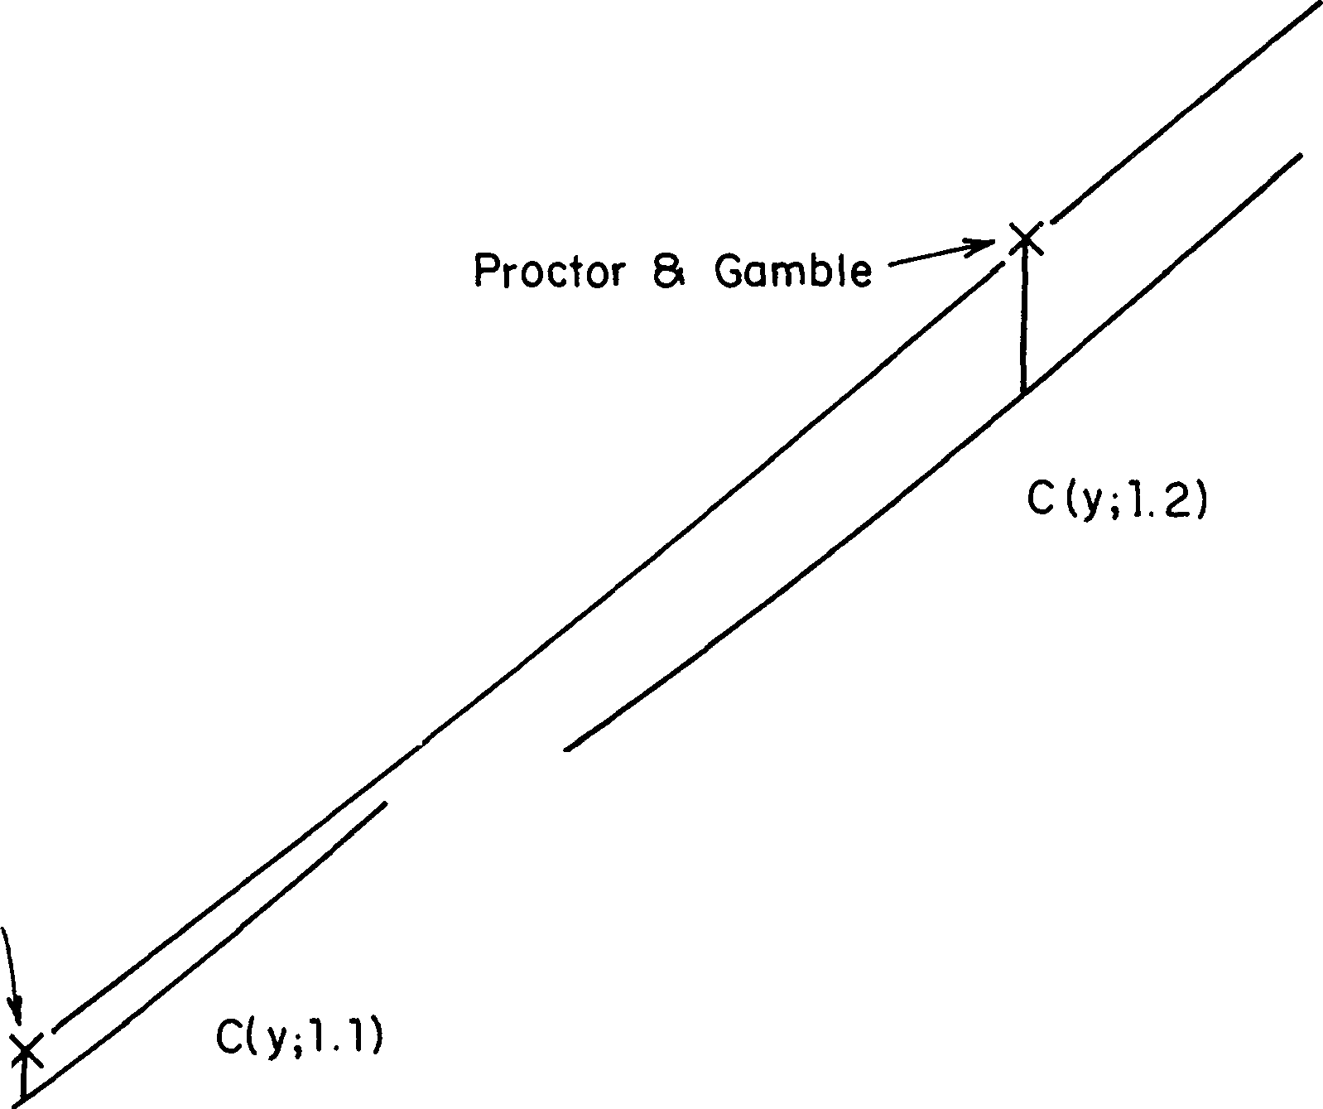$

DISPOSABLE DIAPER MARKET

(Paradox Region, a=l, b=l, c=l.2; d=l 5)

Johnson S

Johnson

KimbzrlyS

Clark

/'

*J/.,_*

1.,(y,1)

1.50

.60

0 1.00 175

Volume y

Fm. 6.-Production volume decisions in the disposable-diaper market, at equilibrium. Equilibrium schedule *W(y): (k* = O; 'Y = 0.7; *00* = 1.313).

table 1, here the increase in cost level requires that higher quality be at­ tributed to each producer in order to predict the same volumes *y,* and the prices and sales volumes actually are increased as a result, as is the cash flow. Again in contrast to table 1, but as in figure 5 for a GRIND market, there is very little sensitivity to changes in the demand level *r.*

Locating U.S. Industrial Markets in the Trade-Offs Plane

In figure 7 (which repeats the topography of fig. 3)16 an abbreviated name indicates the estimated location in the trade-offs plane of each of a score of current domestic markets. Included are the three (cement, airplanes, diapers) just analyzed. The primary source used is a business school case study series with acronym ICCH.16 Table 3 gives ICCH identification codes as well as other sources.

15 No dotted line at *a/c* = 1/-y {s shown because 'Y (crudely: a measure of aggregate elasticity of demand) may be different for each industry. My impressions are that, of the 20 cases in fig. 7, on careful measurement only color TV sets 1965, optical fiber, Mini­ computer 1980, and injectors might prove to have *a/c* beyond the corresponding value of 1/-y (i.e., in the EXPLOSIVE region of fig. 3); and only the first two might have values of 'Y greater than unity.

16 The ICCH series used are but a small fraction of all Intercollegiate Case Clearing House case studies (Graduate School of Business, Harvard University): these are either deliberate studies of a whole industrial market or studies of individual firms which can be combined to yield good coverage of a given market by my definition.

Placement of an industry in figure 7 is an exercise in coding, that is, in qualitative judgment on cost structures and on valuations.17 Occasionally, as for the farm equipment industry, systematic numerical data is given for the quantities of concern so that numerical estimates of parameters can be made.18 Other locations are close to guesses, such as those shown for main­ frame computers and minicomputers.19

TABLE 2

MARKET SCHEDULES AND QUALITY LEVELS WHICH YIELD THE PRODUCTION VOLUMES *(y)* OBSERVED IN THE DISPOSABLE-DIAPER INDUSTRY UNDER VARIOUS CONTEXTS, WITH SHIFT CONSTANT

*k* = -40

Proportion

*n w* Cash Flow Price

Context: *q=I, r=I,* -y=.7

|  |  |  |  |  |
| --- | --- | --- | --- | --- |
| 30 | 3.33 | 10.38 | .058 | .35 |
| 100 | 3.67 | 39.75 | .098 | .40 |
| 296 | 4.00 | 128.5  80=9.2 | .100 | .43 |
| Context: *q=l.2, r=I,* -y=.7 | | | | |
| 30 | 3.61 | 11.07 | .219 | .37 |
| 100 | 3.98 | 42.11 | .249 | .42 |
| 296 | 4.34 | 136.1  6o=9.44 | .250 | .45 |
| Context: *q=I, r=l.2,* -y=.7 | | | | |
| 30 | 3.32 | 10.38 | .058 | .35 |
| 100 | 3.66 | 39.73 | .098 | .40 |
| 296 | 4.00 | 128.4 | .100 | .43 |

Bo=ll.05

Context: *q=* I, *r* = I, *'Y* =.9

|  |  |  |  |  |
| --- | --- | --- | --- | --- |
| 30 | 1.80 | 27.19 | .094 | .91 |
| 100 | 1.98 | 100.2 | .100 | 1.00 |
| 296 | 2.16 | 323.6 | .100 | 1.09 |
|  |  | *Oo=* 1. 975 |  |  |

NOTE.-Throughout *a* = I = *b; c* = 1.2; *d* = 1.5.

17 Six cases were coded independently by Eric Leifer. In each of these the codings agreed on region. In the absence of systematic numerical data, however, exact agreement on location is virtually impossible.

18 I.e., the farm equipment case study quotes tlie proportionate percentage decrease of cost with increase in percentage of (notional) production capacity which is utilized. Depending on tlie particular component reported, tlie exponent *c* lies between 0.7 and 0.9. (See ICCH-9-280-080 [Rev. 2/80], table 5, p. 6.)

19 The tliree illustrative cases presented above range from quite exact coding using numeri­ cal data (disposable diapers) to more qualitative estimates extrapolated across firms (cement).

TABLE 3

SOURCES AND NOTES FOR TWENTY INDUSTRIES

Name (in Fig. 7) and

ICCH Identification* Notes and Other Sources

Drilling mud:

9-380-167 ................. .

9-380-168 ................. .

Vacuum tubes:

1-379-181 ............... .

1-379-184................ .

Watches:

6-373-080................. .

1-374-050 ................. .

1-374-051.. ............... .

9-373-090................. .

Baby foods 1965:

} Market in vibrators to cleanse pollutants from barite

Rev. 8/79 } Classic declining industry

Rev. 8/79

Rev. 10/72) Rev. 10/75

Rev. 10/75 Rev. 9/76

1-379-178................ .

1-379-185 ................ ..

Log houses:

1-378-195 ................. .

1-379-(196-201) ........... .

3-378-193................. .

Circuit breakers:

9-513-152 (M230) .......... .

9-513-151 (M229) .......... .

9-565-004................. .

9-567-005 (AM-P204) ...... .

9-578-205 ................. .

Disposable diapers:

9-380-175................. .

Oil tankers:

9-379-086 .................

Distribution electrical components:

5-379-146.............. .

1-377-063 ................. .

5-379-146...... .. ....... .

3-778-153................ ..

9-377-041................ .

9-380-084................. .

9-377-055 ................. .

Strode's cables:

5-377-028 ................. .

9-376-188 ................. .

9-377-027 ............... ..

Cement 1970s... . . . ........ .

Sugar refining 1895 . . ....... .

Injectors plus electronic fuel injection (EFI):

9-378-219 ................. .

1-378-257 ................. .

Light aircraft:

9-369-007 (BP 934R) ....... .

Rev. 8/79 } Rev. 8/79

}

Rev. 10/75 ] Rev. 1/79

Rev. 10/78

R 1/7I9

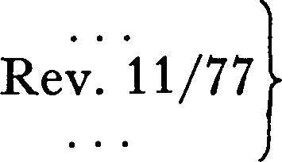

}

Unusually clearcut case of PARADOX

Firms which rationalize customized houses

Smith Barney Harris Upham Research Reports 1979: various <latest

See text.

Service firms that stock tens of thousands of types of parts

Market in metal-ceramic cable con­ nectors, includes Strode division of EG&G, Inc.

*·Business Week* 1980

Eichner 1969, chaps. 2, 3

Injectors are a component of EFI, and a separate market; cases emphasize role structure in these markets

9-369-008 ................ .

9-370-036... . . .. .. ....... .

Rev. 1970 } Low-cost, recreational plane market

* Studies available for a fee from Intercollegiate Case Clearing House, Soldiers Field Road, Boston, Mass. 02163. (Each may run from five to 25 pages of single-spaced pica typescript. Most of these industry studies use real names of firms; some, and most ICCH cases of individual firms, alter data to conceal identity and/or protect confidentiality.)

t Available in business school libraries, unbound,

TABLE *3-Continued*

Name (in Fig. 7) and

ICCH Identification* Notes and Other Sources

Mainframe computer 1980.... .

Minicomputer 1980.......... . Nickel. .................... .

Tractors 1970s:

4-578-083................. .

9-280-080................. .

9-171-368 (BC 349) ........ .

9-313-123 (BP 866) ........ .

9-313-154 (PB 867R) ....... .

9-377-704............ . ... .

9-574-858 ..................

Color TV:

1-380-180 ................. .

1-380-181 ................. .

1-380-191 ................. .

Fiber optics:

Rev. 121/8/707)

Rev. 7/69

}

Corey and Star 1971, pp.108-56; *Harvard Business Review* 1980; *Fortune* 1980

Hayes 1980

Salter and Weinhold 1979, chap. 10

1-379-136..................

1-379-139 ................. .

1-380-117 ..................

Rev. 1/80 Will explode into a cluster of huge new

markets: in my terms, 'Y exceeds unity

Some ICCH case study series contradict the specifications (the "givens") demanded by my model and so do not appear, although those industries might be suitable if studied at another date.20 Another, on the oil tanker industry, can be rephrased to meet the model specifications.21

The firms which participate in many of these markets do so typically as divisions. A separate division, which is an independent profit center and

2o One such is the series on turbine generators after 1963. This is an industry with but two members, a pure duopoly which is not a market in my sense. Prior to 1963, however, it was a market in my sense, one in which several other U.S. and foreign producers joined the two in eyeing one another for the same business. This earlier form I discuss elsewhere (White 1981) on the basis of Sultan's two-volume account (1974, 1975). The late nine­ teenth-century market in sugar refining, ably described by Eichner (1969), also ended as a trust, but with many members rather than two. I would code it as having been in the GRIND region in 1885: some product differentiation (according to impurity level and associated taste) but less than the variation in cost among the score of manufacturers

around the United States *(b* < o). Over the next decade, greatly expanded factories yielded striking economies of scale *(c* < 1). The set of producer firms belongs in the

CROWDED region for 1895 as shown in fig. 7. Then the disappearance of product differ­ entiation set the stage for market instability and the Havemeyers' rounding up of all firms into a trust.

21 lithe volume in this market (the decision variable, y) is number of tanker trips supplied by a charterer, the market is *not* a production market but a truck-and-barter market which should be referred (with its erratic prices and speculative features) to the pure theory of exchange (Newman 1965). But one can reorient to see *y* as the speed at which given tankers are sent on a journey and thus the volume of oil delivered per time period. Figure

7 contains a point for this market, for which the case study material yields quite definite estimates *(c* = 2, *a* < 1, *d* < 0, ii» *b,* 'Y < 1). (The existence of such a market as a separate entity is, of course, an idealization, given its heavy dependence on terms of trade and supplies in the spot market for tankers as well as on the charter market.)

relatively autonomous, is the decision maker eyeing the other producers.22 For example, the ceramic-metal connector market labeled Strode's Cable in figure 7 is that participated in by an independent division of the large firm called EG&G (a division acquired earlier by incorporating an old-line firm named Strode).

X

I

vacuum

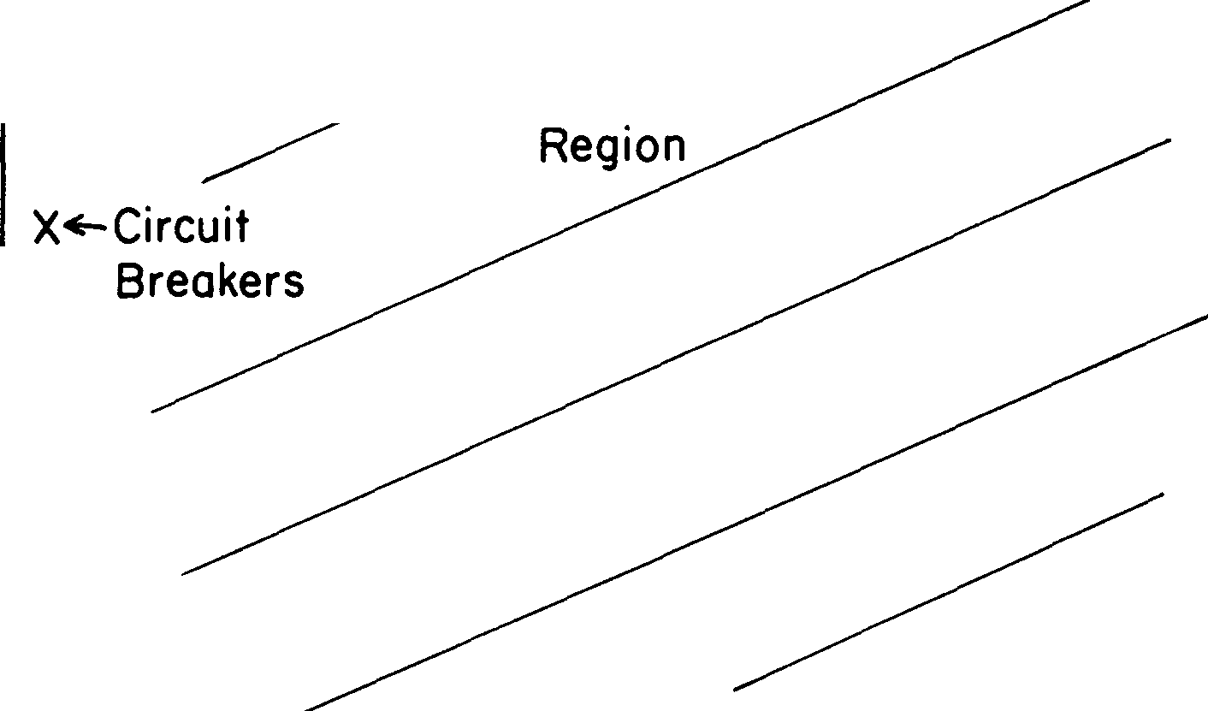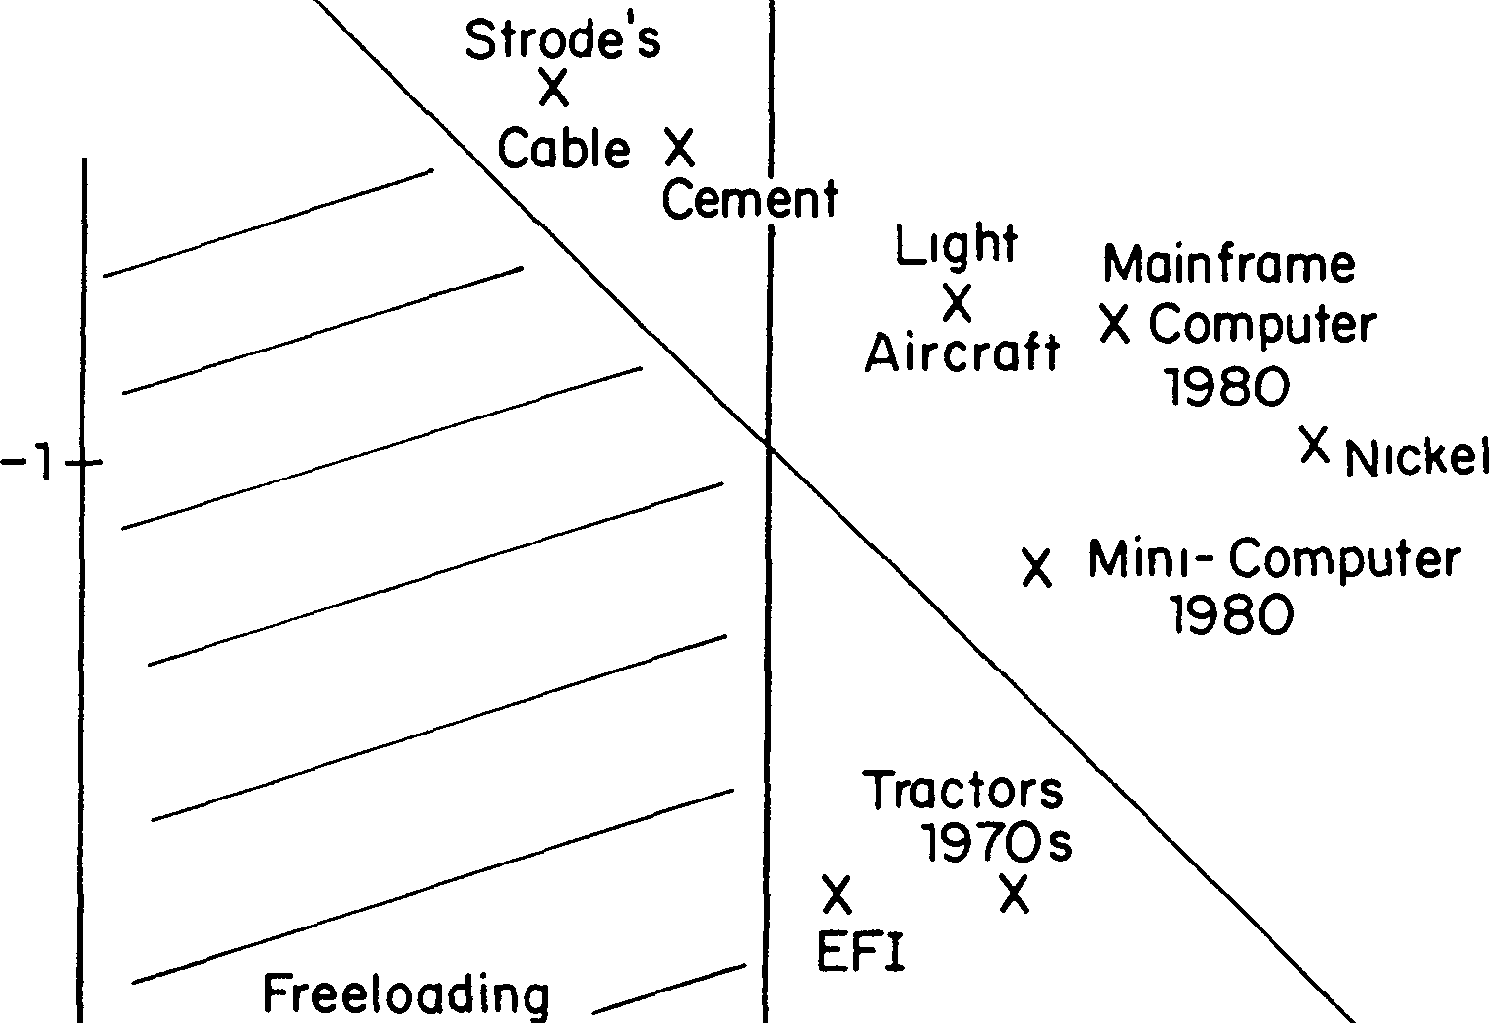

b/d

Drilli g

Mud

Watches

**X**

**X X**

Baby Foods 1965

T:uJbes.198O

Failed

_,

Disp**.x**osable

Diaper

0 k---------+----' _. ale

**X** Distribution

-..._ X

Oil Tankers

Elect Compo.

Sugar Refining

**X**

1895

Tradeoff over Volume

**X**

Injectors

Color TV Sets

X 1965

Failure

Optical X Fiber

FIG. 7.-Locations of markets on the trade-offs plane (sources in table 3)

22 This fact could add obvious cross-market complications, but these may be financial (capital, and long-range costs) and not related to production. My model should be seen as a preconglomerate model.

The ICCH reports on the baby-food manufacturing industry yield a clear-cut and well documented example in the **PARADOX** region, to con­ trast with the diapers market discussed above. In the late 1920s Gerber created and then led an industry for canned baby foods as decisively as IBM did mainframe computers. Gerber, too, has had precursors and early competitors such as Mead Johnson's pabulum of 1915 and Clapp's canned broth, as well as large competitors which perished without a trace (e.g., Libby, McNeill, Birds Eye).

Mothers were convinced enough of Gerber's quality that it could charge price premiums of over 10% while spending nearly 10% less on total advertising and promotion. In 1965 Gerber had more modern and efficient production facilities than its main competitors-Beech-Nut, Swift, Heinz­ which in turn were more efficient than the smaller brand-name competitors, often regional, and the numerous small private-label competitors. Yet econo_mies of scale were not significant, in part because there were so many food varieties (over 100) at a given time as well as a high rate of change of varieties, about one-third per decade.

The large variety of items also tended to limit concentration by buyers on one company's products since other companies offered different varieties that might catch taste. For complex reasons (willingness to give open discounts by volume, or discounts off invoice, or rebates, etc.), supermarkets tended to give Gerber less shelf space than its market share. And contrary to Gerber's and the other companies' predictions, the birthrate had been declining since the late 1950s, and almost all mothers already used the commercial baby foods, so that in 1965 the overall elasticity *'Y* was well under unity.

The constituent estimates underlying the Baby Food 1965 location in figure 7 are *a* = 0.6, *c* = 1, *b* = 1, and *d* = 0.8.28 These differ substantially from those for the diapers market given above in table 2. The resulting

difference in location within the same region of the trade-offs plane leads to substantial differences predicted for other aspects of the two markets (see the next subsection and the Appendix for equations).

Inequality in Market Shares

Since producers watch producers, they are an interrelated set and in the pure case are a clique of mutually aware firms. It follows that there will not be very many firms in a market; probably there will be a dozen or two. Each will tend to be distinct in role and to have a distinct place on the quality index *n.* It follows that the firm which by the existing schedule *W(y)* chooses the largest volume will itself have a substantial share of the market,

23 Furthermore, estimation of the observed terms-of-trade schedule *W(y)* indicates a large, negative value of the shift constant *k.*

as will the next few. One hazards a guess that the smallest firm to which the biggest will lend an eye will be within a factor of 10 in size: thus it follows from my theory that a market is arrayed from a leader with a fifth

or more of the total sales down to the smallest with 1% or so of the total.

But how can we assess these facts in comparison with other sorts of inequal­ ity, or understand them in terms of the trade-off ratios which frame figure 7? I choose this topic of market shares for illustrating my analysis of markets because it seems to me at once one of the most important and one of the most vexed aspects of the present social science understanding of production markets (Scherer 1970; Porter 1980). Observed markets almost entirely escape the computational grasp of existing microeconomic theory (Mansfield 1975; Cohen and Cyert 1975), although by a variety of devices the theory and whatever is observed are declared to be in harmony. Law, in particular antitrust law, seems to shape the concepts more than does microeconomic theory (Williamson [1975]; for a good survey see the last ICCH study cited for circuit breakers in table 3, and for documentation of antitrust policy see Salter and Weinhold [1979], pp. 289-305). The share of total market held by the top four (or 3 or 5 or 8 ... ) producer firms is given prima fade

standing as evidence for degree of collusion in price fixing and so on. In contrast, I think assessment of market share distribution should (i) be made on the basis of an explicit theory of market formation and (ii) be assessed in a more general comparative framework for the study of social inequality. This second objective requires looking at firms as social actors; it also calls for a measure of inequality widely used in social science, such as the Gini index.

Various degrees of inequality among producers in their market shares yield quite different sorts of roles for firms, as well as different overall atmosphere. For example, does the largest firm overwhelm the others with its presence, or does the traditional English industrial flavor prevail, with firms not varying greatly in size "sharing up" the market in genteel fashion? (Dispersion in profit rates, etc., also are important, but they are influenced in part by facts on fixed investments and the like, which my model ignores.) To achieve a simple formula, I sha_ll further restrict myself to market

schedules with *k* = 0.24 In this special case the inequality in cash flow equals the inequality in market volumes, to which I now turn.

The Gini index is familiar as a measure of inequality or dispersion in personal incomes or wealth: it is derived from Lorenz distributions for cumulative percentage of total income versus cumulative percentage of population (see Schwartz and Winship 1980). It is suitable as well for market volumes (see Granovetter [in press] for general theoretical discussion).

24 They are known to be stable in all subregions of fig. 3 except the upper portion of CROWDED; i.e., except for 1/-y > *a/c* > 1, and *a/c* > *b/8,*

This index, call it *G,* varies between zero (for equality) and one (for total inequality). As calibration: for a uniform distribution over income the Gini is 0.33; typical national income distributions have *G* ""' 0.4, and national wealth distributions may have *G* ""' 0.8.

Figure 8 shows how the value of *G* predicted for sales volumes of a market tends to change according to location in the trade-offs plane. Its limitation is that the qualities and number of firms must be kept the same, for this purpose; so the various predictions cannot be checked individually against values computed across an assembly of observed markets such as figure

7.25 The main assumption is that all firms in any given market are spaced

**b/d**

.48 .58 £,7 .82

.5 .6 .71 .84

.53 .64 .75 .87

( --..

.57

.2

.69 .8"0 .90

.5 .11 *.0i*

.33 .82

\

More Equality

*ale*

/

,/

.67

.43

.2

.33

.06

-1

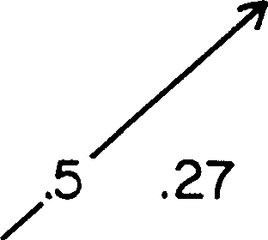

**\*From eq (14):** uniform distribution **of firms ocross all** n (0<n<a>),

**and with k:0.**

FIG. 8.-Gini index scores for inequality in sales among producers (from eq. [14]: uniform distribution of firms across all *n* [O < *n* < oo], and with *k* = 0).

25 In any event there are many practical problems in comparing indices computed from ICCH case studies or from observations in the business press with the projections in fig.

8. Membership in a market as reported may not be that seen by the producers themselves (as my model stipulates): First, various federal definitions (for SIC codes see Shiskin and

uniformly on the quality index *n.* For mathematical simplicity the lower limit and the upper limit of the range for *n* are taken to be zero and infinity,

respectively, and firms are assumed to be very closely spaced on quality. The general formulae for Gunder these assumptions (including *k* = O) are: for physical volume *(y),*

I

for dollar volume *(W),*

G=---,-----1---,----

1+ j *2(c*- *a) b+d*

*G* = 1 .

I I

1+ *2(c*- *a)*

*bc+ad*

(13)

(14)

Note that markets close to the axis where perfect competition lies *(d* » *b)* tend to have high inequality either on sales or on physical volume. Also, inequality decreases by either equation as one moves away from valuation change with volume being proportional to cost change with volume (i.e., as one moves away from the *a/c* = 1 vertical), whether into GRIND and PARADOX regions on the one side or into the CROWDED region on the

other. (The equations do not hold for *lb/di* < *a/c* in the latter, where *k* =

0 is not a stable schedule.)

By inspection of equation (13) one can see that equal physical volumes

are approached when the quality trade-off *b/d* is unity and negative. In the bottom of figure 8 *(d* < 0), when the two trade-off ratios are equal, but

opposite in sign, equality in sales volumes among producers is approached. But it is precisely along this line that market structure disintegrates just because it relies on divergences between cost trade-off and value trade-off to cue distinctive niches for firms.

CONCLUSIONS

Markets are tangible cliques of producers observing each other. Pressure from the buyer side creates a mirror in which producers see themselves,

Peterson [1972]) may yield no statistical "industry" or "product" at all close; yet business journals usually report data in terms of government definitions. Second, the numerical levels of Gini indices for market sales came from a stylized power-law framework for cost and valuation; they do not make accountants' discriminations. Third, most reports of business performance use the legal corporation as unit, but typical *Fortune* 500 firms can have dozens of divisions, which as mentioned above, are commonly the effective actors in the actual markets I model. Reinforcing biases will tend to make predicted values higher than observed values. Eq. (14) assumes an infinite range and uniform distribution for

quality *n* and so should tend to exaggerate inequality; it also assumes a schedule described

by a shift index *k* of zero. Empirical estimates usually come from truncated sets of firms with the smallest omitted and so will tend to underestimate inequality. I see no reason why either of these reinforcing biases should be correlated with the size of *G,* so the rank order of predicted indices should tend to be the same as that for observed indices.

not consumers. Heterogeneous producers with their differentiated products may find and maintain stable roles or niches. Self-interested optimizing by each of them can sustain a global market schedule *W(y),* but it is exposed to three sorts of market failure. Basic limits for equilibrium configurations turn out to depend on just two trade-off ratios which summarize the facts of costs and tastes. Thus markets are shaped by trade-offs between dis­ persions, not by averages as suggested by the cliche that supply equals demand.

APPENDIX

Changes in Cost Level and Product Popularity

Two different kinds of sensitivity of the market as a whole to an exogenous change (see fig. 5), such as an increase in *q* or *r,* should be distinguished. The first is the effect on the market schedule *W(y)* of figure 1. This is a change in height of the price schedule, a scale change in a graph such as figure 4. The second kind is the resultant change, including feedback effects, on the actual volume of sales by each firm and by the market as a whole. The latter, overall resultant is easier to compute: when the shift constant

*k* = 0 (White 1981, eqq. [25] and [26]), all regions yield the same propor­

tionality for the aggregate volume of the market ***W,*** namely,

# (Al)

It befits the nature of market formation, as a balancing of trade-offs in dispersions (see fig. 2), that the market volume varies with valuation scale factor *r* to the exponent *c* of cost variation with volume; and, similarly, dependence of ***W*** on costs scale *q* is through *q* raised to the power *a* of volume's contribution to valuation. But note that market sales total goes down as cost scale goes up. It is also obvious that the sensitivity of market size to either scale factor increases as the demand-saturation exponent rises-as 'Y becomes closer to *c/ a.* Even more obvious is the fact that this net feedback resultant of change in costs or valuation scales on market sales in aggregate does not depend at all on the trade-off *b/d* on the quality dimension! These findings generalize the numerical results presented above for three illustrative markets.

But visible changes in the market schedule *W(y),* the price schedule

perceived by producers, take quite a different form, and this form itself differs according to region in the trade-offs plane of figure 3. Rather than quote the formulae (from White 1981, eqq. [28]-[30]), I have illustrated in the three detailed examples how dramatic the change in form is. And there the changed locations of each individual firm are indicated on the changed schedule.

*Price Structure*

Implicit in the divergence (in text above, eqq. [13] and [14]) between the two Gini indices, for sales volume and for physical volume, is variation of price with volume. The last figure in White (1981) reports the predicted variation in price per unit according to total volumes from various pro­ ducers in that market, separately for subregions of the trade-offs plane. (Only monotonicity and existence of extrema are specified; so the predicted curve holds throughout the given subregion regardless of the particular values on quality index. The simplicity of these shapes follows from my approximation of cost and valuation schedules by families of power func­ tions.) At various locations within one region of the trade-offs plane, the CROWDED region, one can find price-by-volume curves rising monotoni­ cally, or falling monotonically, or concave downward, or concave upward! This plasticity underlines my contention that prices are a secondary and ex post phenomenon.

Consider a numerical price schedule from one of the earlier illustrations, for the light-aircraft industry (with *q* = **1** = *r,* 'Y = 0.7 and take *0* = 1.63, see table **1).** In the schedule with shift constant *k* = 0.5, the price-volume pairs corresponding to Beech, Cessna, and Piper, respectively, are (where *Pn* is price per unit)

|  |  |  |  |
| --- | --- | --- | --- |
| *p,.* | .440 | .414 | .399 |
| *Yn* | 1.0 | 1.6 | 1.9 |
| *n* | .613 | .538 | .503 . |

The *n* values were chosen to yield the observed ratios of sales volumes among light-aircraft manufacturers: higher values mean (as before) higher quality, so that Beech is the Cadillac and Piper the Chevy.

It is difficult to obtain reliable information on effective prices and physical volumes sold for all of the firms in a given market. It is not sufficient to obtain posted price schedules or price books, since these often represent a basis for negotiation more than a reliable report of practices. In any event my model presupposes aggregation of all sales by the given firm into one aggregate volume, and aggregation of the corresponding revenue across a dispersion of concrete sales prices in different batches to different customers.

REFERENCES

Akerlof, George. 1976. "The Economies of Caste and the Rat Race and Other Woeful Tales." *Quarterly Journal, of Economics* 84:599-617.

Alonso, William. 1964. *Location and Land Use: Toward a General, Theory of Land Rent.*

Cambridge, Mass.: Harvard University Press.

*Business Week.* 1980. "Building Up to a Shortage in Cement," no. 2629 (May 5), pp. 138--44.

Cohen, Kalman, and Richard Cyert. 1975. *Theory of the Firm.* 2d ed. Englewood Cliffs, N.J.: Prentice-Hall.

Corey, E. Raymond. 1978. *Procurement Management: Strategy, Organization and Decision­ Making.* Boston: CBI.

Corey, E. Raymond, and S. **H.** Star. 1971. *Organization Strategy.* Boston: Harvard Graduate School of Business Administration.

Dixit, A. **K.,** and J. E. Stiglitz. 1977. "Monopolistic Competition and Optimum Product Diversity." *American Economic Review* 67:297-308.

Eichner, Alfred S. 1969. *The Emergence of Oligopoly.* Baltimore: Johns Hopkins University Press.

*Fortune.* 1980. "IBM's Battle to Look Superhuman Again" (May 19), pp. 106--12. Granovetter, Mark. In press. "Toward a Sociological Theory of Income Differences."

In *Sociological Perspectives on Labor Markets,* edited by Ivar Berg. New York: Academic Press.

Grossman, S. 1975. "Rational Expectations and the Econometric Modeling of Markets Subject to Uncertainty." *Journal of Econometrics* 3:255-72.

*Harvard Business Review.* 1980. Vol. 58 (March-April): 82-94.

Hayes, Thomas. 1980. "Digital's Mastery in Computers." *New York Times* (April 7),

pp. D1-D5.

ljiri, Yuji, and Herbert A. Simon. 1977. *Skew Distributions and the Sizes of Business Firms.*

Amsterdam: North-Holland.

Kantor, Brian. 1979. "Rational Expectations and Economic Thought." *Journal of Eco­ nomic Literature* 17:1422---41.

Lancaster, Kelvin J. 1966. "A New Approach to Consumer Theory." *Journal of Political Economy* 74: 132-57.

---. 1979. *Variety, Equity and Efficiency: Product Variety in an Industrial Society.* New York: Columbia University Press.

Mansfield, Edwin. 1975. *Microeconomics: Theory and Applications.* 2d ed. New York: Norton.

Muth, John F. 1961. "Rational Expectations and the Theory of Price Movements."

*&onometrica* 29:315-35.

Newman, Peter. 1965. *The Theory of Exchange.* Englewood Cliffs, N.J.: Prentice-Hall. Porter, Michael E. 1976. *Interbrand Choice, Strategy, and Bilateral Market Power.* Cam­

bridge, Mass.: Harvard University Press.

---. 1980. *Competitive Strategy.* New York: Academic Press.

Rosen, Sherwin. 1974. "Hedonic Prices and Implicit Markets: Product Differentiation in Pure Competition." *Journal of Political Economy* 82 :34--55.

---. 1978. "Substitution and Division of Labour." *Economica* 45:235-70.

Salter, Malcolm S., and W. A. Weinhold. 1979. *Diversification through Acquisition.* New York: Free Press.

Scherer, F. M. 1970. *Industrial Market Structure and Economic Performance.* New York: Rand McNally.

Schwartz, J. E., and Christopher Winship. 1980. "The Welfare Approach to Measuring Inequality." Pp. 1-37 in *Sociological Methodology* 1980, edited by Karl Schuessler. San Francisco: Jossey-Bass.

Shiskin, Julius, and Milo Peterson, eds. 1972. *Standard Industrial Classification Manual.* Washington, D.C.: Office of Management and the Budget, Statistical Policy Division. Spence, A. Michael. 1974. *Market Signaling: Informational Transfer in Hiring and Related*

*Screening Processes.* Cambridge, Mass.: Harvard University Press.

---. 1976. "Product Selection, Fixed Costs and Monopolistic Competition." *Review of &onomic Studies* 43:217-35.

Steiner, Peter 0. 1975. *Mergers: Motives, Effects, Policies.* Ann Arbor: University of Michigan Press.

Sultan, Ralph G. M. 1974. *Pricing in the Electrical Oligopo/.y.* Vol. 1, *Competition or Collu­ sion.* Boston: Harvard Graduate School of Business Administration.

---.1975. *Pricing in the Electrical Oligopoly.* Vol. 2, *Business Strategy.* Boston: Harvard Graduate School of Business Administration.

Terleckyj, Nestor E., ed. 1976. *Household Production and Consumption.* New York: Columbia University Press (for National Bureau of Economic Research).

White, H. C. 1976. "Subcontracting with an Oligopoly: Spence Revisited." RIAS Working Paper no. **1,** Harvard University, September.

---. 1978. "Markets and Hierarchies Revisited." Mimeographed. Cambridge, Mass.: Department of Sociology, Harvard University, March.

---. 1979. "On Markets." RIAS Working Paper no. 16, Harvard University, April.

---. 1980. "Markets as Social Productions." Mimeographed. Cambridge, Mass.: Department of Sociology, Harvard University.

---. 1981. "Production Markets as Induced Role Structures." Pp. 1-57 in *Sociological Methodology* 1981, edited by S. L. Leinhardt. San Francisco: Jossey-Bass.

Williamson, 0. E. 1975. *Markets and Hierarchies: Analysis and Antitrust Implications.*

New York: Free Press.